®

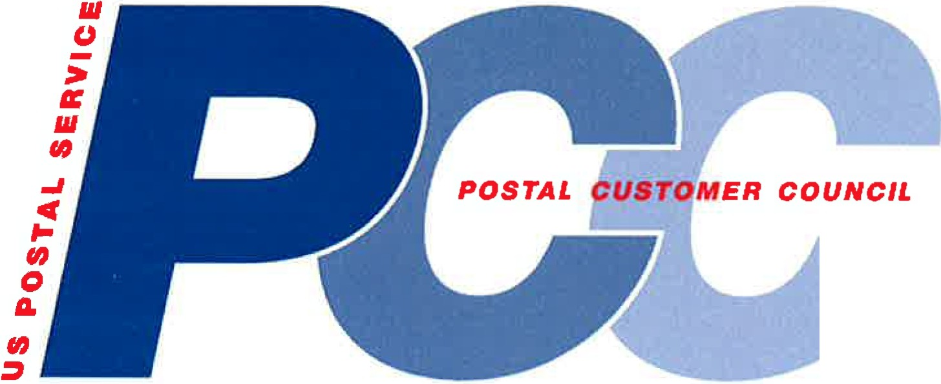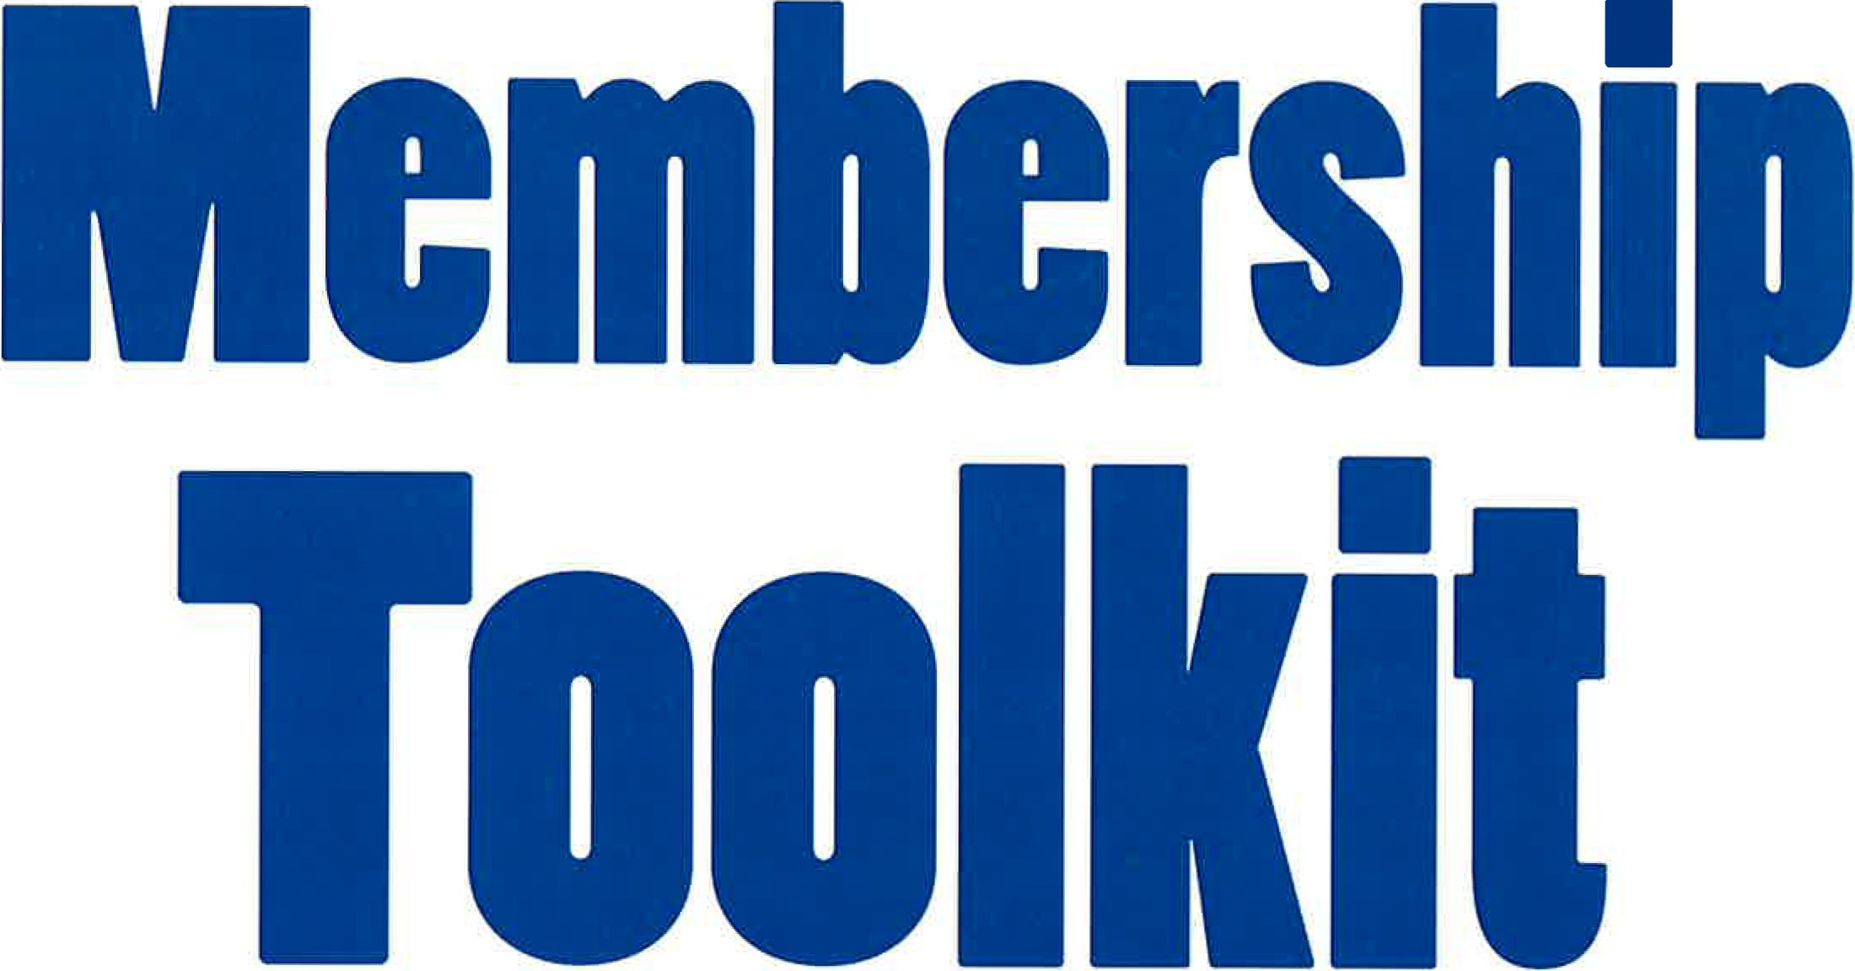

First EdRian-March 20M

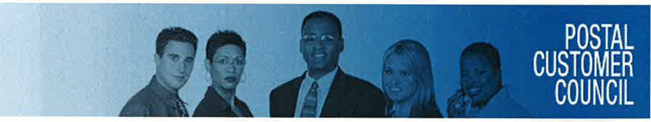

**TABLE OF CONTENTS**

**INTRODUCTION**

• Welcome to the PCC Membership Toolkit

• Benefits of PCC Membership

**MISSION STATEMENT**

• PCC Mission Statement

**BEST PRACTICES/STRATEGIES**

• PCC Best Practices

• Connect with a PCC

• PCC Membership Applications

**TEMPLATES**

• PCC Membership Flyer Template

• PCC E-blast-Email Message Format

• PCC Letterhead Template- Right Justified

• PCC Letterhead Template - Centered

• PCC Letterhead Template- Left Justified

• PCC New Member Welcome Letter

• PCC Newsletter Templates- Long Island PCC Example

**RESOURCES**

• Frequently Visited Website Links- Cheat Sheet

• Find PCC Resources

• PCC Annual Calendar

• Membership Survey Summary Results

• PCC Reporting Template

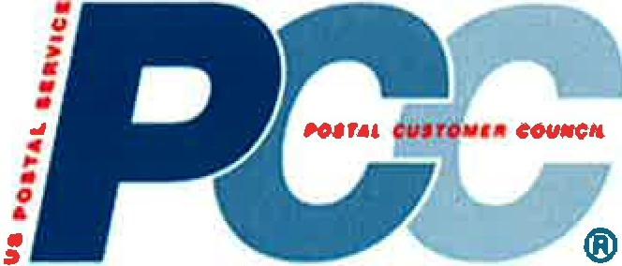

**Welcome to the PCC Membership Toolkit!**

All Postal Customer Councils (PCCs) continue to explore ways to grow and add value to their membership. This PCC Membership Toolkit is intended to help you with that effort. The Toolkit contains best practices, templates and more. These tools should assist you with your membership growth initiatives in ways that save time, money and resources,

Do you have the need to write a letter to acquire new members; what about a new membership application; have you given thought to reaching out to your local Chamber of Commerce, but do not know how to get started; and what about the need to provide the value of PCC membership to prospective new members. *Look no further!* You should review the content of this Toolkit for help.

It should be noted that the Toolkit is a living document. Therefore, please share with us the best practices and templates that have provided great results for your PCC. Please email them to PCC@ usps.gov and they will be included in the next version of this resource.

For suggestions and advice, please feel free to contact the members of the PCC Advisory

Committee (PCCAC) Membership Subcommittee.

*We hope all of you take advantage of this important resource to help grow your PCC membership and good luck!*

**Toolkit completed** by: PCCAC Membership Subcommittee

**Date:** March 2014

**Benefits of PCC Membership**

There are benefits to connecting with a local Postal Customer Council® (PCC). This nationwide network is a great way to get training, stay on top of mail innovations, and work hand-in-hand with a local Post OfficeTM to develop more effective, efficient, and profitable mailings.

**Your local PCC offers these benefits...**

• **Knowledge** - Gain knowledge about postal products, services, and tools to improve mail quality, as well as help grow your business

• **Innovative Ideas** - Learn about promotions and incentives that raise awareness of innovative mail uses

• **Expert Advice** - Hear about how to integrate and expand your marketing through the mail

• **New Sources-** Find new sources for acquiring mailing lists

• **Networking** - Network with other mailers, business mail service providers, and USPS executives and hear first­ hand from others about how they use mail to be more efficient and profitable, as well as face the same challenges you face

• **Best Practices** - Leverage best practices to improve mailing effectiveness, efficiency, and profitability



**PCC Mission Statement**

The PCC is a postal-sponsored organization. The mission of the PCC Program is to:

• Promote local cooperation and support and to foster a close working relationship between the U.S. Postal Service and all businesses that use the mail to communicate and interact with their customers;

• Share information and facilitate the exchange of ideas about new and existing Postal Service products, programs, services, and procedures that affect all businesses that use the mail; and

• Help PCC industry members and their organizations grow and develop professionally through focused educational programs.

**The mission statement of every local** PCC **should mirror this mission statement.**

'

00

Q) 00

u Q)

·r-i ·r-i

+J 01 u Q) ro +J

1-1 ro

IJ.4 1-1

+J

+J t:Jl

00

Q)

III

**Austin PCC builds membership**

**Through direct mail postcard mailings**

For years, the Austin PCC has utilized email-blasts to advertise our monthly educational sessions and general meetings. However, over time our registration had grown stagnant, with the same companies sending the same employees to our events.

Six months ago, we decided to use direct mail in an attempt to boost our attendance. Rather than pay for a list, we used the permit list from our local BMEU. To this we added names and addresses that we've been actively maintaining, just not used recently since we were only

e-blasting. One of our board members volunteered to merge/purge the list and run it through CASS. With this list, we mailed simple black and white postcard mailings for our March, April and May meetings.

Each month we noticed an increase in first-time attendees, from companies we've targeted in the past and new companies who didn't have a clue we even existed. Our May meeting with our District

Manager was the largest number of new faces we have had at a meeting. Twenty-six percent were first-time attendees.

The postcard mailings have made a difference in our attendance.

We will continue to use this medium to reach out to our existing and new potential members.

Capital Region PCC Best Practice, 2012

(S) The Postal SeiVice is currently in a state of flux, with changes in roles and responsibilities among our management personnel occurring frequently. As Network Optimization continues to evolve, now more than ever we need to stay in touch with mailers and more importantly, they need to be able to reach us.

(T) Keep the mailing community, especially those that are not part of the PCC Executive Board, aware of administrative changes in personnel and contact information on a regular basis. While we have provided district directories in

the past, our rapidly changing environment is not conducive to recreating a new directory every time changes occur.

(A) To ensure that local mailers who need information can get it without the frustration of dialing several numbers and not reaching the right person, we decided to provide a list of current managers within the district each time we publish our quarterly newsletter. We title the list, "Important Contacts at the Post Office."

(R) Since including "Important Contacts at the Post Office" in the newsletter, we have received feedback that it is really great to be able to reach, for example, the Bulk Mail SupeiVisor, by calling one telephone number, easily found in the current PCC newsletter. We also post this information on our website. Providing this type of information strengthens the position that the PCC is the conduit between the mailers and the Postal SeiVice and the best source to get current and valuable information.

Area: Northeast

PCC: Fairfield County CT Narne: Lisa Ladone

Date: 06/12/2012

Category: Education

**Description:**

Best Practice - Co-sponsor postal Grow Your Business Day events.

Benefit to PCCs - Increase PCC awareness and membership, provide valuable information to existing membership. Benefit to USPS - Increase attendance and networking opportunities, increase awareness of programs available to mailers

Each quarter Postmasters are required to host "Grow Your Business Day" events on various topics such as Every Door Direct Mail, International Shipping and Direct Mail Hub.

The Farifeild County CT and Greater New Haven PCC's wanted to raise awareness of the value of the PCCs and partnered with the USPS on these events. The two PCCs designed the advertising direct mail pieces, mailed them and provided

support at registration. At the event the PCCs distributed information to attendees, highlighting the benefits of PCCs membership.

As a result of leveraging these partnerships, membership increased by approximately

90 members for the two PCCs combined. Additionally, it helped to strengthen the partnership with the USPS and the PCC.

Area: Northeast

PCC: Greater Hudson Valley

Name: Debra Jones

Phone: 914-697-7294

Email: [debra.jones@usps.gov](mailto:debra.jones@usps.gov)

PCC Title: PCC Administrator

Date: 05/11!2012

Category: Education

**Description:**

We are continuing to partner with the Industry members to present educational workshops that could help members learn how to grow their business. We have also included a membership discount for mailers who attend our events or workshops. We offer two discounted levels; individual and corporate membership. The membership provides them with free or discounted admission to various workshops. To advertise the discount, we use a 123signup (software system) to send information to our customers. One of the features of this system, it allows you to track members and attendees by event and paid membership. By managing the membership, it allows us to determine which members are active, attend particular events such as educational tracks or network and tailor our education and marketing to suit our member needs.

**Results:**

Attendance at the sessions has increased. We are also experiencing the support of new mailers at the events and workshops.

Here are 10 simple ways to motivate your best people:

1. Challenge them

Every top performing employee wants to be challenged on a weekly basis. As you raise your expectations, their performance and job satisfaction will also increase.

2. Give them the opportunity to make a difference

Forget about hiring "the best." Most employees want to use their careers to make a difference in the world. Show them how they can accomplish that through their work at your company. People really do feel a sense of accomplishment after hard work.

3. Give them the opportunity to advance their career

Show every employee where they can go inside your company. Share a detailed vision!

I will never forget in the late 1980's how my IBM Branch Manager, Jim Corgel once took his business card and scratched out his name. He then wrote my name in its place.

Jim was showing me where I could go in the organization.

4. Be one of the leading places to work

Give them bragging rights at every party and family event. How do you think the employees at Apple, Google and Groupon feel right about now? Like business rock stars? You bet!

5. Pay them well

This is not a place to save money in your business. Give your best employees golden handcuffs by paying them above market rate and provide incentives to be the highest paid employee in their field. If you pay the best, you can expect the best.

6. Give them the ability to make decisions on their own

"Empower" is an overused word in business. But, we still need to give employees the ability to make their own decisions and be responsible for their outcome. Employees that are able to have control over their daily environment have a higher level of job satisfaction and stay longer.

7. Be the boss they want to work for

Be someone that all employees can communicate with without fear of judgement. Be available to talk with them as they make their own decisions in your business.

8. State the companies beliefs and values

Publish a company manifesto clearly and ensure that every company action is in harmony with them.

9. Be supportive of their personal goals

Always ask your employees what their personal dreams are over the next 3 years.

Then figure out ways to be supportive in order for them to meet their personal goal(s).

10. Provide complementary team members

Weed out the non performing employees quickly (Everyone knows who they are anyway)

Your local PCC offers these benefits...

• Knowledge- Gain knowledge about postal products, services, and tools to improve mail quality, as well as earn a professional certificate.

• Innovative Ideas - Learn about promotions and incentives that raise awareness of innovative mail uses.

• Expert Advice- Hear about how to integrate and expand your marketing through the mail.

• New Sources- Find new sources for acquiring mailing lists.

• Networking- Network with other mailers, business mail service providers, and

USPS executives and hear first-hand from others about how they use mail to be more efficient and profitable, as well as face the same challenges you face.

• Best Practices - Leverage best practices to improve mailing effectiveness, efficiency, and profitability.

USPS® Postpones Facility Closures in 2014

The United States Postal Service® (USPS®) announced in a January 24,2014 Federal Register notice that Phase 2 of the planned network consolidation and corresponding adjustment of delivery service standards has been postponed. As we reported in earlier e-Tips, the USPS originally laid out their Network Rationalization plan in 2011 with a phased approach to

closing and consolidating various postal facilities and making the necessary service standard

adjustments to correspond with the new service network. Phase 2 of that plan was scheduled to be implemented on February 1, 2014. The USPS goal in closing a large number of processing facilities is to cut costs and optimize their processing network to more closely align with the decreased volumes of mail.

Network facility changes

The first phase of the network optimization plan began in July 2012 and involved 48 facilities.

The USPS halted closures during the busy mailing season of September through December 2012, but resumed the first phase closure plans in January 2013. The USPS again halted the closures after July 2013 for the busy mailing season through the end of the year, and then planned to resume Phase 2 in early 2014. The Phase 2 plan has now been postponed to a future date, which will be announced using a Federal Register notice.

The Plan

The USPS provides detailed information regarding the planned facility consolidations and closures on the RIBBS web site. Their Mail Move Plan is available in Excel spreadsheet format, and is updated on a weekly basis. The USPS also provides information on these planned consolidations on its main web site.

What it means for mailers

So, what does all this mean for mailers? As the consolidations and closures take place, mailers will need to make sure their mailing software solutions- both presort and post-presort- are updated with the most recent postal destination data updates. This includes Labeling Lists, destination drop ship data files (including re-directions), etc. Mailers will also need to pay close attention to the changes in the USPS service standards and monitor mail delivery so that any necessary adjustments can be made to mailing schedules.

To: PCC

Subject: PCC- BestPractices

PCC - BestPractices

Area: Eastern

PCC: Nashville Middle Tennessee

Narne: Barb Izzo

Phone: 615-370-5005

Email: [barbizzo@am-mail.com](mailto:barbizzo@am-mail.com)

PCC Title: Industry Co-Chair

Date: 05/01/2012

Category: Promotion

**Description:**

This year we have made communication to our membership a priority. To that goal we have developed a quarterly newsletter to promote coming events, postal news, and training opportunities.

We have augmented this effort with postcard mailings in an effort to both promote our events and to serve as an event reminder.

We also realized the value of promoting our organization with brochures to increase awareness to what we offer to mailers through education, networking, and insight into postal concerns that can affect their industry.

Our new website offers easy functionality for membership enrollment and dues collection, real time access to DMM Advisories, USPS announcements, event details, and meeting & training documentation.

**Results:**

As a direct result of the increased awareness of the value of membership though the various channels of media we have had growth of new membership surpass the total of the previous three years. This feat is even more amazing considering this growth has taken place in the same year as the initiation of membership dues. The real result of value is that Middle Tennessee mailers are becoming more aware that our

PCC is a resource for training and education of postal issues and that is our purpose and goal.

To: PCC

Subject: PCC- BestPractices

PCC- BestPractices

Area: Eastern

PCC: Nashville Middle Tennessee

Name: Barb Izzo

Phone: 615-370-5005

Email: [barbizzo@am-mail.com](mailto:barbizzo@am-mail.com)

PCC Title: Industry Co-Chair

Date: 05/01!2012

Category: Promotion

**Description:**

This year we have made communication to our membership a priority. To that goal we

have developed a quarterly newsletter to promote coming events, postal news, and training opportunities.

We have augmented this effort with postcard mailings in an effort to both promote our events and to serve as an event reminder.

We also realized the value of promoting our organization with brochures to increase awareness to what we offer to mailers through education, networking, and insight into postal concerns that can affect their industry.

Our new website offers easy functionality for membership enrollment and dues collection, real time access to DMM Advisories, USPS announcements, event details, and meeting & training documentation.

**Results:**

As a direct result of the increased awareness of the value of membership though the various channels of media we have had growth of new membership surpass the total of the previous three years. This feat is even more amazing considering this growth has taken place in the same year as the initiation of membership dues. The real result of value is

that Middle Tennessee mailers are becoming more aware that our PCC is a resource for training and education of postal issues and that is our purpose and goal.

PCC - Best Practices

Area: Northeast

PCC: New Hampshire Name: Linda Martin Phone: 603-644-4047

Email: [lindaann.martin@usps.gov](mailto:lindaann.martin@usps.gov)

PCC Title: PCC Administrator

Date: *0511412012*

Categorys: Education *I* Promotion *I* Membership

Description:

SUSTAINABILITY AND MEMBERSHIP QUALITY DRIVE

The New Hampshire Postal Customer Council (NH PCC) had a mailing list of almost 3500 names, and the average number of seminar attendees was 8-12, with a high of 25 and low of 3, about a 0.30% return on investment. While there were efforts over the years to cull and build the list, we were mailing to a lot of people, for a long period of time,

without getting a solid return on our investment (less than half a percent). The 2012 NH PCC executive board decided we should go greener by reducing the mailing list and, in doing so, craft a higher quality membership file and garner a higher return on investment. We wanted to make every mail piece count.

Results:

• We had just created a NH PCC by-law change proposal for our membership and decided to use this mailing to also include a membership continuation survey. We developed the ballot and business reply envelope for every member currently on the mailing list. A letter came from the Postal Co-Chair that explained the survey, set a deadline for receipt for continued membership, and offered an option to re-join and keep current at our NH PCC web site.

• We passed the file through the National Change of Address (NCOALINK) application prior to mailing.

• We mailed the dual survey to 3368 members on November 28, 2011, with a deadline for receipt of December 15 (we did, however, accept them through the end of January). The survey also asked if they wanted to be added to

the NH PCC confidential e-mail list to receive ongoing communication about postal changes, new products, service disruptions, congressional actions, etc.

• Once all responses were received, the board reviewed those names slated for deletion. Many were past seminar attendees, managed accounts, and these were worth a second look, about 200 names. The board then reached out to these and other members to verify their status in the NH PCC and discovered many folks had retired or otherwise left the company. It was a very worthwhile and needed exercise, and the final list was completed on January 31, 2012.

Results of list culling/add to e-mail solicitation:

• 208 responses received or 6.18%.

• Approximately 200 additional members personally contacted

• Total addresses on mailing list:

o Before = 3368 o After= 225

o Decrease of 93.32%

o Currently= 242 ( +17 members or a 7.56% increase since 1/31/12)

• Total addresses on e-mail list:

o Before = 221 o After= 285

o Increase of 64 addresses or 28.96%

Once we had the final list, our next step was to grow a quality file of members who would actively engage with our programs and events to help us better advance the PCC mission. While we have achieved some of our goals, there are many others in the pipeline for the 2012-2013 PCC year (future best practice).

• Seminar attendance responses:

o Before = Average 10 or 0.30%

o After= Average 27 or 11.75%

o Return on Investment increase of almost 4000%

PCC Best Practices

PCC Name: Greater Portland PCC Area: Western Area

Name: _Tracey Dunlap

Phone: 503.350.5928

Email: [tdunlap@epiqsystems.com](mailto:tdunlap@epiqsystems.com)

Categorys: Promotion *I* Membership *I* Leadership

**Best Practice Description:**

The Greater Portland PCC (GPPCC) created a recognition program highlighting companies that support the PCC for their involvement and participation.

The program includes the Pinnacle Awards with tiered levels -Bronze, Silver and Gold. There are requirements at each level that recognize a company's involvement. The PCC recognizes companies that allow their employees to attend meetings, education programs and Board involvement. Also, the PCC recognizes companies for their support with printing/mailing services, graphic work and other sponsorship opportunities that help to promote and support the PCC.

**Best Practice Results:**

The result is that companies are rewarded for their efforts to support the PCC. The Pinnacle Awards are given out at our annual conference. The Bronze recipients receive a certificate. Silver is recognized with a plaque. The Gold level companies are given a signed and numbered framed piece of artwork

commissioned by a local artist. The artwork is in keeping with our theme: Bridging the Future...Together, USPS and the GPPCC. The bridge pictures are framed and a plaque is inset on the matting denoting the name of the company, name of the award and the date. Companies that receive the award year after year continue

to support the PCC to gain that recognition. The artwork is placed in prominent locations whereby promoting the PCC and honoring the companies for their involvement.

Select Area: Northeast

Select District Name: Connecticut Valley

Name: PCC of Providence RI Contact Phone:: 401-276-6950

Contact Email: [lisa.pontes@usps.gov](mailto:lisa.pontes@usps.gov)

Category: Education *I* Membership

**Best Practice Description:**

The Providence PCC offered an open house to introduce businesses to their local PCC.

We began the night with providing postal and industry members an opportunity

to network. After introductions we talked about the mission of the PCC, the value of membership, how our partnership can benefit our mutual customers. We then provided a very informative and educational overview presentation on Every

Door Direct Mail.

The session was dynamic and interactive which was the key to its success.

We covered the basics with a power point on EDDM and then leveraged a nearby training center that houses 14 computers to allow hands on training and navigation of the EDDM website. We assisted customers through the registration process online and established accounts. Feedback from the attendees was positive.

**Best Practice Results:**

This open house was extremely successful resulting in an overwhelming increase in our membership. The best practice we learned was to not only offer some type of hands-on to get your attendees interested but make it fun and exciting for them to want to get involved and continue their membership. Our PCC continues to grow stronger while increasing our membership.



**Best Practices in Database Management**

**Capital Region PCC**

**Overview-**

* Almost one of every four pieces of mail has some type of problem with the address.

* Over 40 million individuals and businesses move each year.

* Without routine maintenance, address databases deteriorate, at rate of over 2%

per month - that's a 25% error rate in just one year!

* The true cost of returned mail goes well beyond the wasted print and mail cost of the initial mailer. Most importantly, loss of staff time and customer dissatisfaction, are just a few of the consequences to you and/or your business.

**Suggestions-**

* Always validate address accuracy at the *original point of data entry.* If you do not have software to accomplish this, you can use the USPS website, for free lookups.

* Take steps to ensure every address in your database(s) is "real".

* Use either Ancillary Service endorsements on your mail piece or automated

Address Change Service- ACS- to assure return of NIXIE mail.

* USPS-approved software that employs *Delivery Point Validation.* This software can actually verify if a specific address exists or not.

**Solutions-**

*Below are a few best practices that your PCC can implement for database management:*

For Address Cleansing:

* NCOA Link (National Change of address):

* Address Doctor: [www.addressdoctor.com](http://www.addressdoctor.com/)

* Satori Server: [www.satori.com](http://www.satori.com/) This will integrate into Microsoft office & it runs against Delivery point validation. It will link to all spreadsheets in the office.

* U.S. Postal service FREE address lookups @ [www.usps.com](http://www.usps.com/)

* NIXIEs: When a NIXIE is received, if you are using an Excel Spreadsheet, manually change the address.

Backing up Data:

* Use a Memory stick or thumb drive.

* Carbonite. [www.carbonite.com](http://www.carbonite.com/)

Database Tools:

* Excel Spreadsheets

* Microsoft Access

**Summary-**

* Don't delay updating your database when you receive address corrections from your customers or the U.S.Postal Service. Diligence will save you and/or your business both time and money!!

**Connect with a PCC**

The Postal Customer Council® (PCC®) program is a valuable resource for business mailers, large and small. Local PCCs serve as an open channel for USPS®-to-business communication, providing information and best practices for achieving cost-effective and profitable mailing, education and training, as well as solving local challenges. Through regular meetings, educational programs, mailer clinics, and seminars, PCC members learn about the latest postal products and services that may help them grow their business.

**Your local PCC offers these benefits...**

• **Knowledge** - Gain knowledge about postal products, services, and tools to improve mail quality, as well as earn a professional certificate

• **Innovative Ideas** - Learn about promotions and incentives that raise awareness of innovative mail uses

• **Expert Advice-** Hear about how to integrate and expand your marketing through the mail

• **New Sources** - Find new sources for acquiring mailing lists

• **Networking** - Network with other mailers, business mail service providers, and USPS executives and hear first-hand from others about how they use mail to be more efficient and profitable, as well as face the same challenges you face

• **Best Practices** - Leverage best practices to improve mailing effectiveness, efficiency, and profitability

**Find a PCC Near You:**

Find the address of your local PCC group and the contact information for the postmaster, manager, or officer in charge.

**Locate PCC Events in Your Area:**

Find events to attend in your area that will provide you with valuable contacts and information to promote your business.

**Get PCC Education and Training Resources:**

PCC Education provides Postal ServiceTM business customers with information about postal products, services, and tools to help grow their business, as well as improve mail quality. These materials are suitable for all PCC educational events and can be used to create a customized professional certificate program.

**Find PCC Additional Resources:**

Stay informed and find what you need to meet your members' needs and keep your Postal Customer

Council (PCC) activities and programs running smoothly.

**Learn more about Business Mail Training:**

Get hands-on experience with business mail functions, mail management, and supervisory techniques in the Executive Mail Center Management Program.



**Annual Membership Application**



**October 1,** _ - **September** 30,

**Annual Membership Fee** - [$$$] (Includes up to two members per company)

D *New Membership*

D *Renewal Membership*

**COMPANY INFORMATION:**

**Company Name:**

Address: City:

Website Address:

Industry:

ST: ZIP+4:

**PRIMARY MEMBER:**

Name: Title: Telephone: E-Mail:

**ADDITIONAL MEMBER** {If **applicable):**

Name: Title: Telephone: E-Mail:

D Check enclosed payable to: **_ PCC**

D Check # Check Amt. _

MAIL TO:

*Join online at: ___ _ _*

If you have any questions, please send an email to or call (XXX) XXX-XXXX.



**Postal Customer Council Membership Application Year _**

|  |  |  |
| --- | --- | --- |
| **Description** | | **Amount** |
| PCC Membership - Benefits include:  + Postal Updates  + Direct Access to Senior USPS Personnel  + Educational Seminars | | Contributing $  Non-Contributing |
| Company: | o New Membership  o Renew Membership | |
| Primary Company Representative: | Phone: | |
| Address: | Fax: | |
| City, ST ZIP: | Email: | |
| Additional Company Representatives: | Phone/Fax/Email: | |
|  | | |

I would like to serve on a Committee:

o Membership Committee o Programs Committee

How did you hear about us? Select Option:

oMailing oOther _

o Pay By Check

**Payment Instructions**

Make checks payable to _

Complete this form and attach check

Mail to:

Postal Customer Council

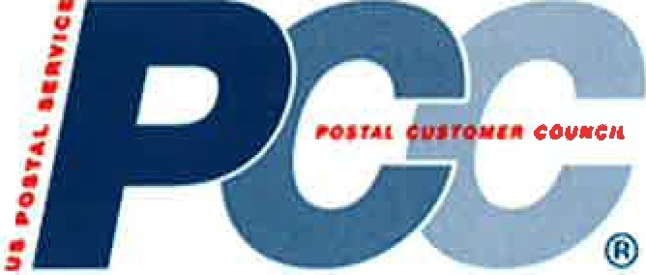

**Membership Growth Best Practices**

**-1. Reach out to your local United Way:** Offer to provide an annual session (no more than 1 hour) on Non-Profit Mailing 101. This session should focus on the definition of non-profit, the value of mailing to a clean list (increased your ROI, decreases waste, keeps donor and member information current), the incentives available (what they mean to them), EDDM, and even basics on size and shape options for maximum postage savings. It should be hosted by the United Way, and include both an industry and postal speaker.

**..I. Use your local Chambers of Commerce:** Joining a Chamber of Commerce gives you access to a wide number of businesses - many of whom are not even aware of the power of the mail. Ask to speak at one of their events and use your time (about 15- 20 minutes) to give them specific examples of how mail can work for businesses. Ideas could include package services, EDDM, list rentals, self-mailers, using a QR code, size and shape options, etc. (Workshop not currently available through the PCC Advisory Committee (PCCAC).) Be sure to have handouts, including a sign-up sheet to join your PCC!

**..,j. Add value for your Sponsors and Mailers:** Survey your sponsors and mailers to determine what kind of programs their customers and prospects need. Arrange an event specifically for mailers to invite their customers and prospects to. The focus can be *Mailing Ideas for the Non-Mailer* and explain incentives, new piece design ideas, mail visibility and/or other applicable products and services. Invite your Sponsors and PCC members to contribute (not sell) through a panel discussion. (Workshop presentation to be developed.)

**-1. Augment your mailings with a rented list:** When you have a specific topic for your Program, you need to target specific mailers/businesses to attend. Do not be afraid to rent a list (hopefully using your PCC members to provide professional guidance on list selection.)

""" **Augment your mailing lists by sending valuable information on programs to local newspapers, association newsletters, and business group websites.** This means you have planned in advance, as information usually needs to be in several weeks before an event.

**'Oil. Ask your sponsors to *link* to your PCC website.** Do not be afraid to ask your members to link their websites to your PCC website to enhance their website and provide opportunities for new mailers and businesses to find you.

**..I. Develop a flier, describing the benefits of your PCC, for your Business Mail Entry Units (BMEUs), Postmasters, Business Service Network (BSN) representatives and other PCC business members.** (There is at least one sample template invitation in the PCC Toolkit.)

**.ol. Invite school participation.** Meet with local high schools, colleges and trade schools. If they have a design or business program, invite them to a special session on the value of the mail; ask the teachers/administrators to join the PCC, so their students learn about the industry. Use students to help with PCC committees, like communications; arrange to speak at local schools for a 20 minute presentation on a related topic -like *Business Mail- What is it; How to use it.* (Workshop presentation to be developed.)

**,;,i. Database Management.** Without routine maintenance, address databases deteriorate, at rate of over 2% per month - that's a 25% error rate in just one year! Always validate address accuracy at the *original point of data entry.* If you do not have software to accomplish this, you can use the Postal Service website, for free lookups: [www.usps.com.](http://www.usps.com/) Do not delay updating your database when you receive address corrections from your customers. *Diligence will save your PCC both time and money!*

March 2014



POSTAL



• CUSTOMER

···. COUNCIL

®

**Join the Postal Customer Council and start**

**networking to build your business.**

[Insert Name of PCC]

If two heads are better than one, imagine what a whole group of like-minded people can accomplish.

That's the idea behind the Postal Customer Council (PCC). PCCs bring together Postal and

industry executives, local business people, and mail-related vendors who share your goals- and the determination to meet them. Your PCCs provide education and host business meetings, vendor events, seminars, and mailer clinics all aimed at helping you:

• Take advantage of the latest Postal information, resources, and tools to help your business

• Learn the most effective and profitable ways to market through the mail from Postal experts

• Exchange insights and ideas with other local businesspeople

• Receive discounts to major mailing industry events

Start networking today to take advantage of the many PCC benefits that can help grow your business. There's a place for you in the PCC.

To find out how you can join, or for more information on upcoming meetings or events, just contact your PCC coordinator listed below.

You may also sign up for the *PCC Insider* newsletter- an easy way to stay up-to-date on the latest news and issues impacting the mailing industry, as well as learn more about the U.S. Postal Service® and the PCC. Just visit *usps.com/pee* to subscribe to the PCC Insider or learn more about the PCC.

PCC Coordinator: Telephone:

E-mail:



The U.S. Postal Service Long Island Business Mail Entry Department would like to welcome you to attend...



**INTELLIGENT MAIL & MOVE UPDATE SEMINAR**

DATES:

3 Sessions Offered (Select One of Three)

• Friday, March 20, 2009 9 AM- 12 PM or

• Monday, March 23, 2009 9 AM - 12 PM or

• Monday, March 23, 2009 1 PM - 4 PM or

LOCATION:

U.S. Postal Service

Business Service Network

65 Maxess Rd

Melville NY 11747-3158

COST:

There is "No Cost" to attend but an RSVP is Required: Nancy Daniels @ Business Mail

Entry Office at (631) 755-2931

**Please note that the presentation will last between 2 - 3 hours in length, so please plan accordingly.

The Postal Service is shifting to new mailing standards for the use of Intelligent Mail® barcodes effective May 11, 2009. To help our customers understand how the use of Intelligent Mail®

barcodes will impact their mail operations and to explain Move Update and Service Standard

developments we are hosting a DVD and discussion presentation.

At the presentation we will show you:

• How the use of the Intelligent Mail® services will enhance the value of your mail

• Discuss certain requirements that are necessary to qualify for either the "Basic" option or the "Full-Service" option

• Cover the increase in the minimum frequency of Move Update processing and the extension of the Move Update standards to include Standard Mail

• Describe the Move Update options that are available to help mailers

improve the quality of their addresses and the return on their

investments.

U.S. Postal Service Long Island

Business Mail Entry Department

65 Maxess Road

Melville NY 11747-3158

631.755.2931

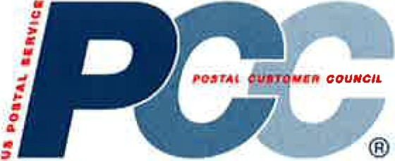

***POSTALCUSTOMERCOUNCIL***

Begin your text here.

Lorem ipsum dolor sit amet, consectetuer adipiscing elit. Donee at eros eget Iibera imperdiet tincidunt. Pellentesque habitant morbi tristique senectus et netus et malesuada fames ac turpis egestas. Ut lacinia, felis ac vulputate eleifend, lacus lacus congue risus, eget facilisis lacus ante id urna. Ut ac lorem. Donee id ipsum. Proin vitae leo sed neque pulvinar elementum. Aliquam dolor lacus, nonummy sed, porttitor et, placerat at, erat. Praesent venenatis convallis nisi. Nunc enim ante, tempor ac, nonummy id, accumsan vel, nisi. Maecenas et diam. Donee aliquet pellentesque neque. Etiam volutpat nulla a arcu. Donee ac lectus vel felis viverra porta. Donee egestas faucibus urna.

Nullam quam urna, molestie at, congue id, semper a, ligula. In ullamcorper quam. Aenean congue justa sit amet mauris. Mauris mi justa, rutrum vitae, iaculis et, malesuada ac, dolor. Pellentesque feugiat congue orci. Class aptent taciti sociosqu ad litora torquent per conubia nostra, per inceptos hymenaeos. Fusee odio. Aenean velit. Donee tellus augue, rhoncus nee, faucibus non, volutpat vitae, felis. Duis dapibus lacus in Iibera. Proin lacinia augue nee turpis dictum imperdiet. Donee eu mi. Curabitur tristique faucibus arcu. Quisque vestibulum rutrum erat. Mauris turpis. Phasellus sit amet nunc faucibus massa eleifend scelerisque. Cras Iibera enim, rutrum nee, gravida eu, hendrerit vel, nunc.

Ut auctor aliquet est. Mauris nulla odio, aliquam a, volutpat ultrices, tincidunt non, felis. Proin mollis suscipit purus. Donee rhoncus mattis mi. Ut tincidunt ipsum vitae est. Phasellus ultricies odio vitae lorem blandit ullamcorper. Fusee pretium metus egestas velit. Duis auctor bibendum nunc. In hac habitasse platea dictumst. Nunc tincidunt iaculis risus. Quisque condimentum odio a orci. Fusee condimentum. Fusee vulputate lacus in purus. Ut enim risus, rhoncus sit amet, dictum vel, nonummy et, lectus. Proin porta lacus sit amet ante. Suspendisse hendrerit ultrices magna. Vivamus eu Iibera. Maecenas in leo ac metus molestie tincidunt.

Vestibulum ante ipsum primis in faucibus orci luctus et ultrices posuere cubilia Curae; Nullam sagittis sagittis sem. Curabitur sed est. Nunc eros arcu, accumsan ut, ultricies et, eleifend eu, lectus. Proin dictum pretium urna. Nullam velit leo, fringilla sit amet, sagittis quis, elementum id, dui. Duis blandit, ligula sit amet pulvinar viverra, velit felis dignissim nisi, eget congue diam ante vitae elit. Vivamus risus. Pellentesque adipiscing scelerisque purus. Curabitur eget nibh non eros accumsan condimentum. Aliquam erat volutpat. Suspendisse hendrerit. Cras non nisi. Aenean arcu nisi, feugiat eget, imperdiet sed, porta id, enim.

Vivamus ipsum velit, eleifend vel, vehicula id, vulputate sed, odio. Quisque enim tellus, suscipit vel, blandit luctus, auctor vitae, quam. Cras rhoncus sodales massa. Duis ut sem ac metus accumsan adipiscing. Nunc consectetuer. In sapien. Sed ultrices molestie ipsum. Cras tincidunt augue non metus. Nam dolor nisi, laoreet id, laoreet id, feugiat in, ipsum. Vivamus dapibus, tellus non pharetra nonummy, metus elit pellentesque nulla, aliquam nonummy nulla velit a elit. Curabitur pulvinar nunc sit amet mi. Aliquam pretium nisi eu nunc. Nam a justo sed erat eleifend nonummy.



***POSTAl CUSTOMERCOUNCil***

Begin your text here.

Lorem ipsum dolor sit amet, consectetuer adipiscing elit. Donee at eros eget Iibera imperdiet tincidunt. Pellentesque habitant morbi tristique senectus et netus et malesuada fames ac turpis egestas. Ut lacinia, felis ac vulputate eleifend, lacus lacus congue risus, eget facilisis lacus ante id urna. Ut ac lorem. Donee id ipsum. Proin vitae leo sed neque pulvinar elementum. Aliquam dolor lacus, nonummy sed, porttitor et, placerat at, erat. Praesent venenatis convallis nisi. Nunc enim ante, tempor ac, nonummy id, accumsan vel, nisi. Maecenas et diam. Donee aliquet pellentesque neque. Etiam volutpat nulla a arcu. Donee ac lectus vel felis viverra porta. Donee egestas faucibus urna.

Nullam quam urna, molestie at, congue id, semper a, ligula. In ullamcorper quam. Aenean congue justa sit amet mauris. Mauris mi justa, rutrum vitae, iaculis et, malesuada ac, dolor. Pellentesque feugiat congue orci. Class aptent taciti sociosqu ad litora torquent per conubia nostra, per inceptos hymenaeos. Fusee odio. Aenean velit. Donee tellus augue, rhoncus nee, faucibus non, volutpat vitae, felis. Duis dapibus lacus in Iibera. Proin lacinia augue nee turpis dictum imperdiet. Donee eu mi. Curabitur tristique faucibus arcu. Quisque vestibulum rutrum erat. Mauris turpis. Phasellus sit amet nunc faucibus massa eleifend scelerisque. Cras Iibera enim, rutrum nee, gravida eu, hendrerit vel, nunc.

Ut auctor aliquet est. Mauris nulla odio, aliquam a, volutpat ultrices, tincidunt non, felis. Proin mollis suscipit purus. Donee rhoncus mattis mi. Ut tincidunt ipsum vitae est. Phasellus ultricies odio vitae lorem blandit ullamcorper. Fusee pretium metus egestas velit. Duis auctor bibendum nunc. In hac habitasse platea dictumst. Nunc tincidunt iaculis risus. Quisque condimentum odio a orci. Fusee condimentum. Fusee vulputate lacus in purus. Ut enim risus, rhoncus sit amet, dictum vel, nonummy et, lectus. Proin porta lacus sit amet ante. Suspendisse hendrerit ultrices magna. Vivamus eu Iibera. Maecenas in leo ac metus molestie tincidunt.

Vestibulum ante ipsum primis in faucibus orci luctus et ultrices posuere cubilia Curae; Nullam sagittis sagittis sem. Curabitur sed est. Nunc eros arcu, accumsan ut, ultricies et, eleifend eu, lectus. Proin dictum pretium urna. Nullam velit leo, fringilla sit amet, sagittis quis, elementum id, dui. Duis blandit, ligula sit amet pulvinar viverra, velit felis dignissim nisi, eget congue diam ante vitae elit. Vivamus risus. Pellentesque adipiscing scelerisque purus. Curabitur eget nibh non eros accumsan condimentum. Aliquam erat volutpat. Suspendisse hendrerit. Cras non nisi. Aenean arcu nisi, feugiat eget, imperdiet sed, porta id, enim.

Vivamus ipsum velit, eleifend vel, vehicula id, vulputate sed, odio. Quisque enim tellus, suscipit vel, blandit luctus, auctor vitae, quam. Cras rhoncus sodales massa. Duis ut sem ac metus accumsan adipiscing. Nunc consectetuer. In sapien. Sed ultrices molestie ipsum. Cras tincidunt augue non metus. Nam dolor nisi, laoreet id, laoreet id, feugiat in, ipsum. Vivamus dapibus, tellus non pharetra nonummy, metus elit pellentesque nulla, aliquam nonummy nulla velit a elit. Curabitur pulvinar nunc sit amet mi. Aliquam pretium nisi eu nunc. Nam a justa sed erat eleifend nonummy.

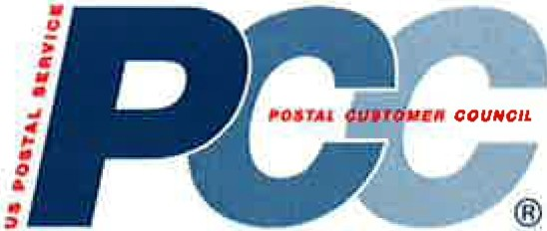

***POSTAl CUST0/1118COUNCil***

Begin your text here.

Lorem ipsum dolor sit amet, consectetuer adipiscing elit. Donee at eros eget Iibera imperdiet tincidunt. Pellentesque habitant morbi tristique senectus et netus et malesuada fames ac turpis egestas. Ut lacinia, felis ac vulputate eleifend, lacus lacus congue risus, eget facilisis lacus ante id urna. Ut ac lorem. Donee id ipsum. Proin vitae leo sed neque pulvinar elementum. Aliquam dolor lacus, nonummy sed, porttitor et, placerat at, erat. Praesent venenatis convallis nisi. Nunc enim ante, tempor ac, nonummy id, accumsan vel, nisi. Maecenas et diam. Donee aliquet pellentesque neque. Etiam volutpat nulla a arcu. Donee ac lectus vel felis viverra porta. Donee egestas faucibus urna.

Nullam quam urna, molestie at, congue id, semper a, ligula. In ullamcorper quam. Aenean congue justa sit amet mauris. Mauris mi justa, rutrum vitae, iaculis et, malesuada ac, dolor. Pellentesque feugiat congue orci. Class aptent taciti sociosqu ad litora torquent per conubia nostra, per inceptos hymenaeos. Fusee odio. Aenean velit. Donee tellus augue, rhoncus nee, faucibus non, volutpat vitae, felis. Duis dapibus lacus in Iibera. Proin lacinia augue nee turpis dictum imperdiet. Donee eu mi. Curabitur tristique faucibus arcu. Quisque vestibulum rutrum erat. Mauris turpis. Phasellus sit amet nunc faucibus massa eleifend scelerisque. Gras Iibera enim, rutrum nee, gravida eu, hendrerit vel, nunc.

Ut auctor aliquet est. Mauris nulla odio, aliquam a, volutpat ultrices, tincidunt non, felis. Proin mollis suscipit purus. Donee rhoncus mattis mi. Ut tincidunt ipsum vitae est. Phasellus ultricies odio vitae lorem blandit ullamcorper. Fusee pretium metus egestas velit. Duis auctor bibendum nunc. In hac habitasse platea dictumst. Nunc tincidunt iaculis risus. Quisque condimentum odio a orci. Fusee condimentum. Fusee vulputate lacus in purus. Ut enim risus, rhoncus sit amet, dictum vel, nonummy et, lectus. Proin porta lacus sit amet ante. Suspendisse hendrerit ultrices magna. Vivamus eu Iibera. Maecenas in leo ac metus molestie tincidunt.

Vestibulum ante ipsum primis in faucibus orci luctus et ultrices posuere cubilia Curae; Nullam sagittis sagittis sem. Curabitur sed est. Nunc eros arcu, accumsan ut, ultricies et, eleifend eu, lectus. Proin dictum pretium urna. Nullam velit leo, fringilla sit amet, sagittis quis, elementum id, dui. Duis blandit, ligula sit amet pulvinar viverra, velit felis dignissim nisi, eget congue diam ante vitae elit. Vivamus risus. Pellentesque adipiscing scelerisque purus. Curabitur eget nibh non eros accumsan condimentum. Aliquam erat volutpat. Suspendisse hendrerit. Gras non nisi. Aenean arcu nisi, feugiat eget, imperdiet sed, porta id, enim.

Vivamus ipsum velit, eleifend vel, vehicula id, vulputate sed, odio. Quisque enim tellus, suscipit vel, blandit luctus, auctor vitae, quam. Gras rhoncus sodales massa. Duis ut sem ac metus accumsan adipiscing. Nunc consectetuer. In sapien. Sed ultrices molestie ipsum. Gras tincidunt augue non metus. Nam dolor nisi, laoreet id, laoreet id, feugiat in, ipsum. Vivamus dapibus, tellus non pharetra nonummy, metus elit pellentesque nulla, aliquam nonummy nulla velit a elit. Curabitur pulvinar nunc sit amet mi. Aliquam pretium nisi eu nunc. Nam a justa sed erat eleifend nonummy.



**EXAMPLE NEW MEMBER LETTER: MODIFY AS NEEDED FOR YOUR LOCAL PCC**



(Date) (Name)

(Address)

(CITY) (ST) (ZIP+ 4) Dear ( ):

**Welcome to the (XXX) Postal Customer Council (PCC)!** You are invited to become an active member of one of most productive and effective mailing organizations around. The PCC® Program is a valuable resource for business mailers, large and small. Local PCCs serve as an open channel for USPS®-to-business communication, providing information and best practices for achieving cost-effective and profitable mailing, education and training, as well as solving local

challenges. Through regular meetings, educational programs, mailer clinics, and seminars, PCC members learn about the latest postal products and services that may help them grow their business.

As a member of the **(XXX) PCC,** you will learn about promotions and incentives that raise awareness of innovative mail uses as well as how to integrate and expand your marketing through the mail. In addition, you will have the opportunity to network with other mailers, business mail service providers, and Postal executives and hear first-hand from others about how they use mail to be more efficient and profitable, as well as face the same challenges you face.

**The mission of the Postal Customer Council Program is to:**

• Promote local cooperation and support and to foster a close working relationship between the U.S. Postal Service and all businesses that use the mail to communicate and interact with their customers;

• Share information and facilitate the exchange of ideas about new and existing Postal Service products, programs, services, and procedures that affect all businesses that use the mail; and

• Help PCC Industry members and their organizations grow and develop professionally through focused educations programs •

PCC activities are organized by an Executive Board that works to ensure that the interests of all mailers are represented. Please complete the **enclosed PCC Membership Application.** We

hope you take advantage of all the **(XXX) PCC** has to offer you and your company. If you have any

questions, please **contact directly at (XXX-XXX-XXXX).**

We look forward to meeting you at our next meeting. Sincerely,

**xxxxxxxxxxxxxx**

**PCC Postal Co-Chair**

**xxxxxxxxxxxxxx**

**PCC Industry Co-Chair**

Enclosure



Volume 8, Issue 3

March 2014- Long Island

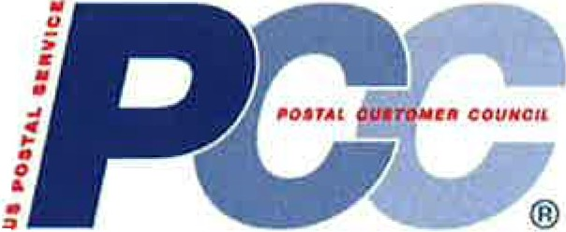

Ll PCC EXECUTIVE OFFICERS

LORRAINE G. CASTELLANO UNITED STATES POSTAL SERVICE Postal Co-Chair

lorraine g.castellano@usps gov

AMY FESTA-KEALEY BROADRIDGE FINANCIAL SOLTUIONS, INC. Industry Co-Chair

amy . fest a@ broadridge.com

MICHAEL VIGNOLA MAILMEN INC

[mvignola@ mailmeninc. com](mailto:mvignola@mailmeninc.com)

ADAMAVRICK DESIGN DISTRIBUTORS, INC adam@designdistributors com

ROCCO POZZULO LAZARUS DIRECT

r [o](mailto:occop@lazmkt.com)[ccop@lazmkt.com](mailto:ccop@lazmkt.com)

DOUG BRANCH MAILTECH MAILING SYSTEMS, INC. doug@ mailtech.com

**************************

Executive Officer Meetings:

9:30am- 10:00 am

All General Meetings:

10 00 am- 11:00 am

Long Island PCC

65 Maxess Road Melville NY 11747-3158 (631) 755-2900

[www.](http://www/) longislandpcc.com

**Long Island Postaland lndustrv Co-Chair Corner** For those who came out for the *Mail Design Professional Program,* thank you very much for your support. For those who didn't, you truly missed an "Only in PCC" experience. Although the commitment of two (2) days made people a bit apprehensive at first, *the amount of information presented was amazing.* We have had nothing but an extremely positive response from attendees.

Many thanks to the crew in the Consumer & Industry Contact group for hosting the event, and many thanks to Kyle Moore, U.S. Postal Service Contractor from Norman, OK, for the brilliant instruction he provided. Kyle made the trip from Oklahoma leaving for Long Island just before the storm and heading for home after the storm. We would like to applaud Kyle and all attendees that were able to weather the storm and be present for this class.

The 2014 National Postal Forum (NPF) is quickly approaching. The NPF will be held on *March 16-19 at the Gaylord National Resort and Conference Center near Washington, DC.* The NPF's continuing goal is to develop an educational program that showcases innovative uses of mail and inspires participants to explore new opportunities for growing their businesses.

The 2014 forum will include new training sessions and networking opportunities for mailing industry professionals. For more information, or to register, go to [www.npf.org](http://www.npf.org/) today!

Since the 2011 Mobile Barcode Promotion, the Postal Service has been creating promotions and incentives to create awareness of innovative uses of mail. By encouraging customers to adopt and invest in technologies that enhance how consumers interact and engage with mail, we fundamentally improve the long-term value of the product which will provide substantial benefits in future years.

*Our next PCC event will be our Wednesday, March 12th meeting which will have a presentation on the 2014 Postal Promotions.* This presentation will provide you with the information on what promotions are currently available and the best marketing practices you can use to take advantage of these promotions. Get a lift in response to your direct mail offers, and save money by maximizing your direct mail investment.

REGISTER NOW! Sign up for all Ll PCC meetings and events on our Ll

PCC website at [http://www.longislandpcc.com.](http://www.longislandpcc.com/)

*See you on March 1ih!*

Lorraine G. Castellano

•

Postal Co-Chair

Amy Festa-Kealey

Industry Co-Chair

Volume 8, Issue 3

March 2014- Long Island

Ll PCC BOARD MEMBERS

A To Z Printing & Mailing

Access Direct Systems Inc Action Addressing & Mailing Services Advertising Distributors of America Inc Alpha Omega Group Of NY Inc

Bell and Howell Broadridge Financial Solutions Inc Brokers Worldwide

Cherry Lane Printing and Mailing Command Business Products Inc CompuMail Business Services Conformer Products Inc

D P Murphy

Datumeg Inc Design Distributors Inc Dix Hills Water District

***NEW* METERED MAll PRICE**

With the price change effective January 26, 2014, the Postal Service™

implemented a new "meter price" for single piece non-presorted First-Class

Mail® letters. The meter price is available for any single piece First-Class Mail

letters with postage paid by meter, permit imprint, pre-cancelled stamps, business reply mail permit (BRM), or PC Postage®, including customized postage. It is available for single-piece First-Class Mail letter mail whether it is mailed at retail (dropped off at a retail counter or dropped into a blue USPS collection box) or as a residual piece in a commercial mailing. The price for up to one ounce is 48 cents.

All existing requirements for Single-Piece mail remain unchanged. For Permit Imprint mailings, the minimum piece requirement of at least 200 pieces per mailing continues to apply.

As shown in the table below, the new price category is based on incremental weights up to 3.5 ounces and is one cent lower than the single-piece stamped machinable First-Class Mail letter price. Postal Service employees should not mark these pieces as postage due when they are one cent below the stamped price.

Note that the one cent difference between stamp and meter pricing is for First-Class letters only; metered First-Class Mail cards and flats continue to have the s

|  |  |  |  |
| --- | --- | --- | --- |
| ame pn·ce as stam p | ed F1rst -Class Ma1·1 card sand flats. | | |
| Weight Not Over  (ounces) |  | First-Class  Letter  STAMP Price | First-Class Letter  METER Price |
|  |
| 1 | 0.49 | | 0.48 |
| 2 | 0.7 | | 0.69 |
| 3 | 0.91 | | 0.9 |
| 3.5 | 1.12 | | 1.11 |

DML Envelope

Eastern Suffolk BOCES Envelopes. com *I* Action Envelope Fulfillment Plus Inc

Hofstra University

J McGrath Mailing Services Inc

Lazarus Direct Lorraine Gregory Corp Mailmen Inc

Mailtech Mailing Systems Inc

MBS Insight Inc MVS Mailers Inc Nassau BOCES National Grid

Neopost NY/NJ Metro Newsday Media Group PCI Group Inc

Pitney Bowes Inc

Pitney Bowes Presort Services

**Senate legislation *gets***

**Positive Reviews**

Legislation designed to help USPS restore financial stability and make basic

improvements in its business model has passed a key congressional

committee and is headed to the full U.S. Senate for further consideration.

The Postal Service said S.1486 provides the framework to return the organization to financial stability. The bill also provides USPS with the necessary flexibility to develop innovative products and services for the American public and to grow the business. "We look forward to continuing to work with the Senate, as S.1486 progresses," USPS said in the statement.

If the full Senate approves S.1496, it must be reconciled with legislation under consideration in the House before a unified bill goes to the president for his signature. Senate leaders have not yet scheduled a time for debate on tr­ proposal.

Volume 8, Issue 3

March 2014- Long Island

Ll PCC BOARD MEMBERS Cont.

Proforma Executive Business Services Publishers Clearing House Richner Communications Inc R1coh lnfoPrint Solutions

Sir Speedy Printing and Marketing Services

Suffolk County Government (DPW) The CPW Group

Town of Hempstead

United States Postal Service

Verizon

William Charles Printing Company

William Lea

**MAllDESIGN PROFESSIONAlPROGRAM** Despite Winter Storm Pax rearing its nasty conditions on day two, the Mail Design Professional (MOP) Program was a rousing success.

The attendees were taught how to design mail to enhance its compatibility with the U.S. Postal Service® automated equipment. They also learned how to achieve lower postage prices through automation.

All 15 attendees that completed the two day training will receive Certification for attending and passing this course, which will be good for two (2) years. For those who came out for the *Mail Design Professional Program (MDP),* thank you very much for your support. Companies Represented: ABGPrint.com; Action Addressing; Adelphi University; Broadridge Financial Solutions; Brooks Litho & Digital Group; DP Murphy Co Inc; Lazarus Direct; NYCB; Pitney Bowes Presort Services; Puritan's Pride; SnaiiWorks; Stony Brook University; Suffolk County DPW

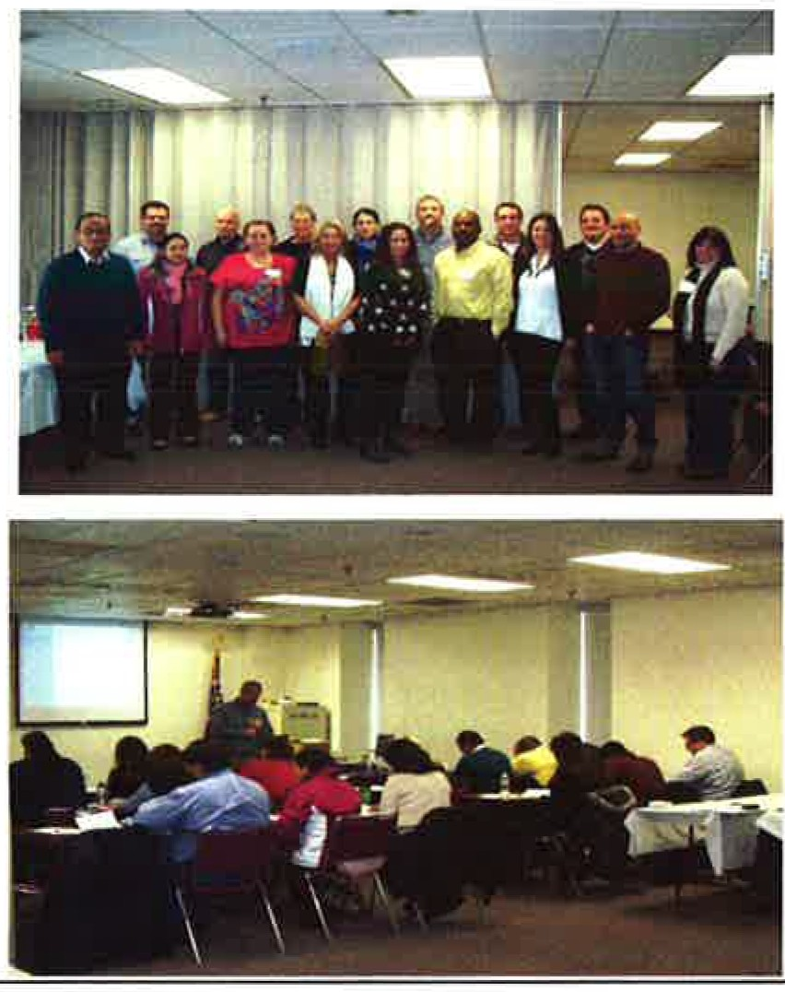

The Ll PCC has a three (3) tier membership based customer partiCipation and involvement with the

NOTE: The Ll PCC does not collect any fees or dues to become any type of member.

General: General membership is open to all business mailers who use the services of the Postal Service.

Executive Policy Board: This group is comprised of individuals from industry and postal employees. This is the planning group of the Council (also referred to as the PCC Board members or Policy Committee members). Members MUST attend a combination of five (5) Ll PCC meetings or events per year and must participate in at least one of the Sub-Committees established by the Council.

Executive Officers: Ll PCC Executive Officers consist of a Postal Co-Chair, Industry Co-Cha1r, First Vice-Chairperson, Secretary & Treasurer Executive Officers are elected to serve for a two (2) year term.

Special discounts and promotions offered to all qualified Executive Policy Board members throughout the year

A copy of the Ll PCC financial report is available for anyone to view if interested.

**2014 NationalPostalForum INPFJ**

**March16 -19, 2014**

The 2014 NPF "Stronger Together" theme focuses on the value we bring each other through education, meaningful collaboration and new innovations in technology. The power of uniting top resources within the mailing industry in an energizing venue provides the fuel needed to propel businesses forward - which is what Stronger Together and the 2014 NPF is all about.

The NPF is the only venue where so many top USPS Executives take the floor to share inside information on current and future events that are shipping today's mailing industry. Plus, the NPF's robust education offering includes more than

130 workshops across 4 mailing industry-focused tracks. You'll also have the opportunity to strengthen ties with industry professionals during numerous networking events.

***REGISTER TODAY!* Go to** [**www.npf.org**](http://www.npf.org/)

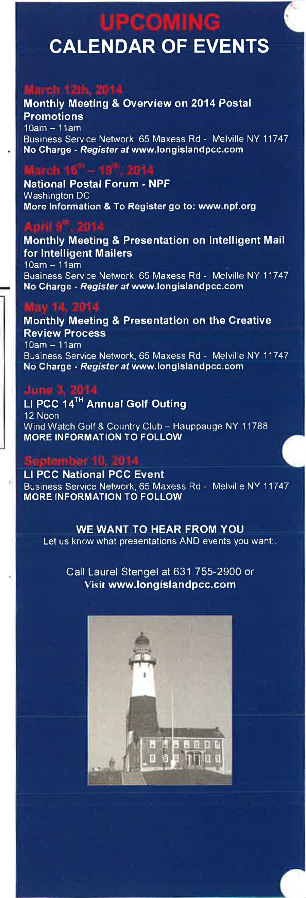

**March Monthlv Meeting**

**2014 Postal Promotions**

Wednesday, March 12, 2014

Come hear what Postal promotions are currently available. Louis Figurito, U.S. Postal Service Sales Executive Sr. will provide you with an overview on these promotions and some best practices being used. Learn how to get a lift in response to your direct mail offers and how you can save money while maximizing your direet mail investment.

There is no cost to attend but you MUST pre-register.

*Space Is Limited*

Attendees will get 1 Credit for this session in the

"Mail Marketing" Track

This event will take place at the Business Service Network located at

65 Maxess Rd- Melville NY 11747-3158

**iThanks to our March Breakfast Sponsor**

**Hofstra University** Hempstead NY 11549 (516) 463-6600

hofstra.edu

"No endorsement by the Postal Service or the PCC is given or implied by this acknowledgement."

*Please register at* [*www.longislandpcc.com*](http://www.longislandpcc.com/)

**Long Island PCC**

65 Maxess Road, Melville NY 11747-3158

Phone: 631-755-2900

Fax: 631-755-2905

E-mail: [laurel.a.stengel@usps.gov](mailto:laurel.a.stengel@usps.gov)

WE'RE ON THE WEB!

**MEMBERS CORNER:**

We would like to *WELCOME* our newest Ll PCC General Members:

-American Solutions for Business -Giobegistics

*Congratulations-* The Ll PCC has issued four (4) "Professional Certificates of Completion" to recognize Ll PCC members who have successfully completed the "Mall Production" Track.

These certificates are part of the *Professional Certificate Program* which encourages and recognizes customers who have attended (4) four presentations within a specific area of learning or "Track", Customers who participate ta stay educated on the latest mailing standards, while staying current on industry practices *are* to be commended.

The Ll PCC's Mission is to:

• Foster and maintain a close working relationship between mailers and the United States

Postal Service.

• Share information about new and existing Postal Service products, programs, regulations, and procedures.

• Facilitate the interchange of ideas among mailers and Postal Service officials.

• Help members and their organizations grow and develop professionally through focused educational programs.

Please help us by contributing news to Amy Festa-Kealey at email [amy.festa@broadridge.com](mailto:amy.festa@broadridge.com) or Laurel Stengel at [laurel.a.stenget@usps.gov](mailto:laurel.a.stenget@usps.gov)

*Newsletter Printing* & *Mailing Donated by-* Broadridge Financial Solutions Inc

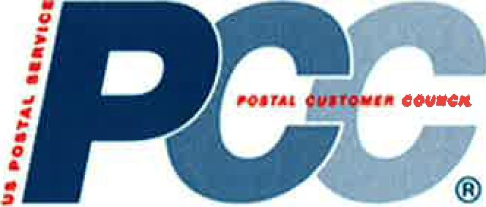

**Frequently Visited Website Links**

**Cheat Sheet**

**.a. National PCC Home Page:** https://[www.usps.com/business/pcc-get-involved-and-qrow.htm?](http://www.usps.com/business/pcc-get-involved-and-qrow.htm)

**4 Connect with Other PCCs:** https://[www.usps.com/business/connect-with-a-pcc.htm](http://www.usps.com/business/connect-with-a-pcc.htm)

**.U. PCC Education *(Workshops):*** https://ribbs.usps.qov/index.cfm?paqe=pccworkshopbox

.. **PCC Best Practices:** Currently on PCC Blue Share site (internal access only) contact your local PCC Administrator

**4 PCC Awards Criteria:** Currently on PCC Blue Share site (internal access only) contact your local PCC Administrator

**4 PCC Policies and Practices:** <http://about.usps.com/publications/pub286.pdf>

**.U. Rapid Information Bulletin Board System *(RIBBS):*** https://ribbs.usps.qovlindex.cfm

**4 Industry Outreach:**  https://ribbs.usps.gov/index.cfm?page=industrvoutreach

**4 MTAC Meetings and Presentations:** https://ribbs.usps.qov/index.cfm?page=mtac

**4 Postal Explorer:** <http://pe.usps.gov/>

**4 US Postal Service Business Mailing Pricing:** [http://dbcalc.usps·.com/](http://dbcalc.usps/)

**4 Business Customer Gateway:** https://ribbs.usps.qov/index.cfm?paqe=intellmailgateway

.. **USPS Service ALERTS:** <http://about.usps.com/news/service-alerts/welcome.htm>

**4 National Postal Forum:** [www.npf.org](http://www.npf.org/)

March 2014

**Find PCC Resources**

Find the materials you need to meet your members' needs and keep your Postal Customer Council® (PCC®) activities and programs running smoothly.

**News & Updates I Resources & Information I Tools & Systems**

**News & Updates**

**PCC Insider Industry** •

PCC Insider® is your source for news about the U.S. Postal Service®, Postal Customer Council (PCC) activities, and issues that affect the mailing industry.

**Register today for the PCC Insider a-newsletter** •

**National & Premier Accounts News & Information**

Keep up with important mailer news and bulletins, as well as find other useful resources.

**NPF- National Postal Forum** •

The Forum's goal is to provide education to business mailers and communication/feedback between the USPS® and its business customers for a more responsive and efficient mail communications system.

**Postal Bulletin** •

The Postal Bulletin serves as the official source of updates to Postal Service policies and procedures.

**USPS News** •

Get the latest news and information about our organization,

**USPS Service Alerts** •

Consumers, small businesses, and commercial mailers can get information about postal facility service disruptions due to weather-related and other natural disasters.

**Resources & Information**

**Rapid Information Bulletin Board System (RIBBS®)** •

This system provides up-to-date information on mail restoration programs, impacted delivery areas, and the latest on postal and mailer news, as well as helpful links, locators, and calculators.

Get more information on the following USPS topics...

• Address Quality

• Business Forms

• Centralized Account Processing System (CAPS)

• Domestic Mail Manual (DMM®)

• MaiiPro

• National Postal Customer Council (PCC) Website

• Network Distribution Center (NDC)

• PCC Insider

• Postal Periodicals and Publications

• Postage Price Tables

• Postal Bulletin

• Postal Explorer®

• Quick Service Guides

• Shipping Supplies

**Visit the RIBBS site index** •

MTAC- Mailers' Technical Advisory Committee •

The Mailers' Technical Advisory Committee (MTAC) is a venue for sharing technical information with mailers and to receive their advice and recommendations on matters concerning mail-related products and services.

DMM Advisory •

The Domestic Mail Manual provides the mailing standards of the United States Postal Service.

Find Area Focus Groups •

The Postal Service® supports forums that meet with members of the First-Class Mail®, Periodicals, and Standard Mail® industries to discuss and find solutions for service issues, share information and ideas, and provide opportunities to work with industry and postal management.

All Forms and Publications •

Every form and publication we offer can be found here. Menu items make it easy to find the forms and publications you need.

Network Distribution Centers (NDCs) >

Formerly known as Bulk Mail Centers (BMCs), the BMC network has been re-engineered into a new system of Network Distribution Centers (NDCs). This network consolidates the processing of originating mail into fewer sites to increase operational efficiency, decrease costs, and maintain excellent service while expanding the suliace transportation reach for more products. This change to our BMCs is an internal network change that doesn't affect the general public.

Intelligent Mail® >

Intelligent Mail products and services use machine-readable codes, such as barcodes, to uniquely identify mail. Large mailers can follow the progress of their mail through the many stages of processing all the way to delivery. This helps businesses to better manage their resources and expenses.

**Tools & Systems**

BMEU- Business Mail Entry Unit >

A Business Mail Entry Unit (BMEU) is a USPS facility that processes bulk business mail. Mailers submit business mail for below retail prices to a BMEU. BMEU acceptance employees are responsible for verifying the mail to ensure that mailings are prepared to business rnail price standards and that revenue is collected in a timely fashion.

BSN- Business Service Network '

The Business Service Network (BSN) is a nationwide network dedicated to providing service support to the business customers.The BSN assists major mailers in the resolution of service issues, information requests, and address validation assistance related to Carrier Pickup and Pickup On Demand services.

BSN eService •

Business Service Network eService is a state-of- the-art program that allows customers to create and monitor service requests online 24 hours a day,

7 days a week.

Verify and Transport Your Mail '

Verify important mail date and get your mail moving with convenient USPS applications.

MDA - Mailpiece Design Analyst Support Center >

The Mailpiece Design Analyst (MDA) Support Center is a centralized agency that routes Mailpiece Design requests from customers to MDAs who have specialized industry expertise, providing services such as information about Intelligent Mail®, mailpiece analysis and review, and hand held templates.

Service Standards '

The Service Commitments application provides service standards for a mailing service based on the entered ZfPTM criteria.

electronic Mail Improvement Reporting (eMIR) through the *Pasta/One!* System '

eMIR provides an effective process for notifying mailers of irregularities in the preparation of mail they present to the Postal Service.

ePUBWATCH >

The ePUBWATCH system allows registered publishers to record subscriber complaints in a single database -a centralized source of information to assist us in pinpointing systematic delivery problems.

Facility Access and Shipment Tracking (FAST®) >

The FAST application allows customers to schedule drop ship appointments and provides advance notification of mailings. This lets USPS better match resources with the expected workload. The FAST application inteliaces with dock systems, like TIMES, VTAPS, and Suliace Visibility to automatically close and track appointments.

**Greater Main Street PCC Calendar of Events**

|  |  |
| --- | --- |
| January 20, xxxx | Workshop: New Shipping Prices |
| Feb 15, xxxx | !Executive Board Meeting |
| March 24, xxxx | Workshop: New Mailing Service Prices |
| April 15, xxxx | Spring Fling: Boat cruise |
| May 17-20, xxxx | National Postal Forum |
| July 15, xxxx | Tour Postal Facility |
| August 6, xxxx | Executive Board Meeting |
| September 16, xxxx | National PCC Week: 2 Workshops |
| October 13, xxxx | Executive Board Meeting |
|  | |
| November 3, xxxx | Workshop: IMpb Impact on Returns |
| December 10, xxxx | Annual Holiday Luncheon |

!

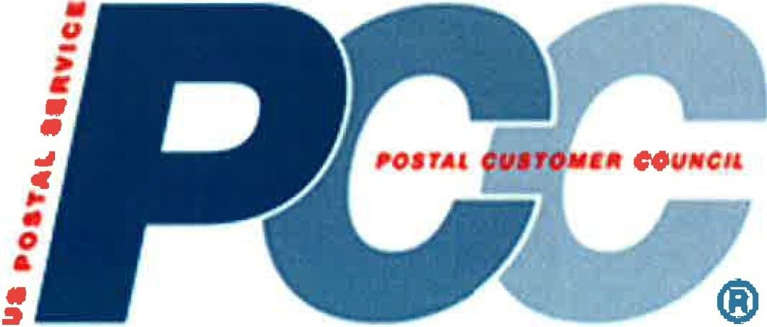

PCC Membership Survey Results Summary

(November 2013)

There were 235 responses to the survey, with most PCC's making multiple entries.

Key Insights:

•75% of all responses indicate that *no membership fees* are charge to join the PCC.

•65% of all responses indicate that membership is defined as *active or inactive, on the current mailing list (no dues charged)*

•20% of all responses define membership as *active individuals* who regularly attend events.

•The activity rated with the highest impact on increasing membership is

*developing relationships with other business groups*



**[PCC Name] Treasurer's Report**

(Reporting Period: mm/dd/yy - mm/dd/yy)

**Beginning Balance as of [mm/dd/yyyy]**

**Revenue/Receipts/Deposits**

**$0000.00**

Dividends/Earned Interest Membership dues/fees Sponsorship donations (cash)

Educational seminars/workshop fees

Vendor shows/exhibits fees

Other (explain)

$0.00

0.00

0.00

0.00

0.00

0.00

|  |  |
| --- | --- |
| Total Revenue/Receipts/Deposits | $0.00 0.00 |
| **Balance Before Disbursements/Expenses** | **$0000.00** |
| **Executive Board Meetings** |  |
| Facility: |  |
| Rooms | $0.00 |
| Food | 0.00 |
| Other | 0.00 |
| **General Membership Meetings** |  |
| Flyers | 0.00 |
| Postage | 0.00 |
| Insert and Mailing | 0.00 |
| Registration Materials: |  |
| Awards | 0.00 |
| Door Prizes | 0.00 |
| Badges | 0.00 |
| Refund/Credit Card | 0.00 |
| Facility: |  |
| Rooms | 0.00 |
| AV/Electric | 0.00 |
| Food | 0.00 |
| Other | 0.00 |
| **Newsletter** |  |
| Printing | 0.00 |
| Pre-Press | 0.00 |
| Postage | 0.00 |
| Insert and Mailing | 0.00 |
| **Membership Promotion** |  |
| Printing | 0.00 |
| Postage | 0.00 |
| Insert and Mailing | 0.00 |
| List Rental/Purchase | 0.00 |
| Other | 0.00 |

**Educational Seminars/Workshops**

Registration Materials

Facility:

0.00

Other

Rooms AV/Electric Food

0.00

0.00

0.00

0.00

**Online Service** Web site design Maintenance Other

0.00

0.00

0.00

**Administrative Services** Fixed Fee Services Hourly Fee Services

Out-of-Pocket Expenses

Audit

Other

Total Disbursements/Expenses

0.00

0.00

0.00

0.00

0.00

($0.00) (0.00)

**Ending Balance as of mm/dd/yyyy] $0000.00**

**Financial Notes:**

1. xxxxxxxxxxxxxxxxxx

2. xxxxxxxxxxxxxxxxxx

**Prepared by: Date:** mm/dd/yyyy

2